Workbooks

**Preschool (Ages 3 & 4)**

**Get Ready for Pre-K**

($12.98 US)

Purchase on Amazon

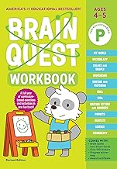**Pre-K (Ages 4 & 5, entering Kindergarten in the fall)**Brain Quest ($5.72 US)Purchase on Amazon